Ski Lift Lines in the Time of COVID-19

  - Reed Kottke
Note: The terms ski resort, ski hill, ski lift, skier, rider and customer are used often and ambiguously to refer to resorts, hills, lifts and skiers/snowboarders – all of which do not differentiate between skiers and snowboarders.

[Abstract]
We aim to find the number of skiiers that should be allowed on the ski hill, abiding by COVID-19 safety protocols, that both maximizes the number of tickets sold (to maximize profits for the ski hill companies) while keeping lines at a reasonable length (to deliver an enjoyable experience to the skier). We will consider the experience a failure if any skier must wait in line for longer than five minutes. Using simulation, we were able to determine a reasonable number of ski tickets that should be sold on any given day to achieve this goal.
[Background and Description of Problems]
Despite significant losses at the end of the 2019-2020 ski season because of COVID-19 induced closures, many ski resorts have experienced a resurgence in customers as interest grows for an outdoor activity. To ensure the safety of guests many ski resorts have mandated policies ensuring that only members that arrived at the resort together share a ski lift chair together - and are therefore already exposed to each other in a COVID-19-risk capacity, minimizing the spread to other skiers at the resort. This is contrary to standard protocol in non-COVID-19 times in which ski lift chairs are filled up to capacity much like elevators: if there’s a spot open and a person free to fill it, it gets filled. Given limitations on sharing ski lifts with strangers, ski lifts are carrying less people per chair. This reduction in capacity causes longer lines at the ski lift.
This simulation is slightly different than existing ski hill simulations that would otherwise assume ski lift chairs are filled to maximum capacity. Still, we will need to (1) identify appropriate metrics for the simulation, including distributions and constants, (2) build the simulation and (3) run the simulation with various quantities until we find an appropriate result.
The ski hill we are simulating does not match any existing hill but is rather a simplified version of an average Midwest United States ski hill, combining the average attributes of many hills into a composite but semi-realistic ski hill. A group of skiers will arrive at the ski hill, ski multiple times, and eventually leave the ski hill. The key difference in introducing the COVID-19 protocols will be treating out skiers as a group of skiers rather than just an individual skier.
Data related to hypothetical ski hill
[Ski Hill Time of Operation] – Our hill will open at 9 AM and the lifts will stop allowing new customers at 9 PM
[Customer Arrivals] – Customers arrivals following a Poisson distribution with decreasing frequency throughout the day. We will assume 50% of all the skiers that will arrive at the ski hill that day arrive between 9 AM - 12 PM, 40% arrive between 12PM – 6PM and 10% arrive between 6 PM – 9 PM. (See Arrival Time Evidence in Appendix)
[Number of People in Ski Group] – When customers arrive, we note how many people are in their party. By tracking the number of riders on each chair at Cascade Mountain, a ski hill in Wisconsin, we were able to gather data that could be used to simulate the distribution of riders in each party. . An assumption is made that the members of any one chair lift are a party and parties larger than four are represented as multiple individual parties each less than or equal to four. By doing this, we can treat these parties as our customer entity, where the number of skiers in each party is an attribute of the customer pseudo-randomly generated.
[Staying Time] – Ski parties will stay for a fixed amount of time, usually around 5 hours. Thus, we will give each ski party a ‘Staying Time’ value in hours from a Normal Distribution with mean 5 and standard deviation 1.
[Time Skiing Downhill] – Using a bit of trigonometry and the below [Speed], [Descent Angle], and [Height], we can come up with a transposed Triangular distribution for the time it takes a ski party to get down the hill: Triangular (lower limit: 1.97 minutes, mode: 2.96 minutes, upper limit: 3.95 minutes).
[Speed] – The average recreational skier travels between 10 – 20 mph. We will use a Triangular distribution with lower limit = 10, mode = 15, upper limit 20.
[Descent Angle] – For our hill, we will assume a middle-of-the-road descent slope of 25 degrees.
[Height] – For our hill we will use the height of Cascade Mountain in Wisconsin: 460 ft
[Time between Ski Lift Chairs] – 5 seconds.⁴
[Length of time on Ski Lift] – This will be a fixed value of 3.5 minutes. We determine this using the length of the ski hill (again using trigonometry) and the speed of a standard ski lift
[Main Findings]
Running the simulation with a modifiable input variable of ‘Total Number of Ski Parties’, the intention was to evaluate the “Maximum Wait Time” at the “Ski Lift”. If the maximum wait time exceeded five minutes for any ski party, we count this as a failure and adjust the input variable and rerun.
The simulation operates as such:
- Create Ski Parties
- Assign a leaving time for the ski party
- Assign a number of skiers in each party
- Use the ski lift
- Wait on ski lift
- Ski Down the hill
- Decide to continue skiing (step 4 again) or leave
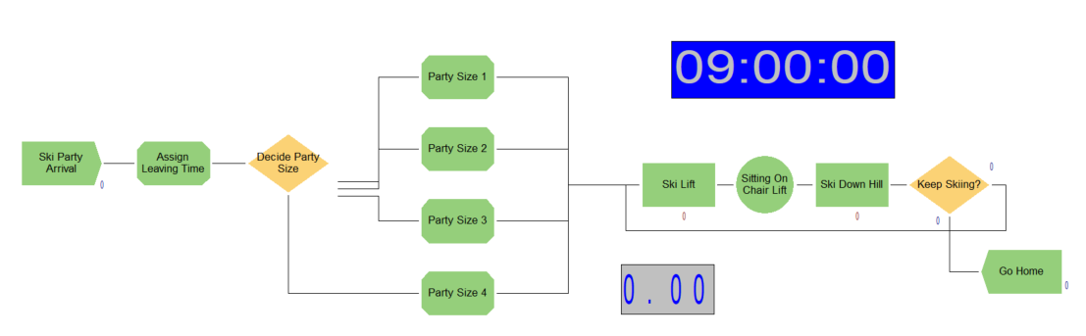
The first problem we ran into was the “150 Entity” cap on the student version of Arena. Due to the repetitive nature of entities using our resources, we tend to have many entities in the system before departing. To get around this, we ‘scaled down’ to keep below the 150 Entity cap, and then ‘scaled up’ the results to fit the original entries. For example, if we reduce the number of ski parties by a factor of eight: 1000 ski parties become 125 ski parties, the length of time on the ski lift of 3.5 minutes becomes .4375 minutes and the time skiing downhill of Triangular(2, 3, 4) becomes Triangular(.25, .375, .5). The wait time of the five minute threshold remains, but we have to translate the ‘Total Number’ of skiers and ‘Number of Ski Parties’ back by multiplying by 8.
We are using bisection to determine the optimal number of ski parties on a given day. Each run is an aggregate of ten simulation runs, each lasting twelve hours (the length of hours of operation for the ski hill). We keep track of a variable called ‘Total Skiers’ that counts how many skiers are in each party; that way we can translate back from ‘Ski Parties’ to ‘Total Tickets’ the ski hill should sell.
The findings were as such:

Real | Average(Min) | Max(Min)
1000 | 2.95 | 6.38
900 | 2.76 | 5.72
800 | 2.24 | 5.19
700 | 1.88 | 4.55
750 | 1.98 | 4.44
775 | 2.34 | 5.32
760 | 2.20 | 4.51
767 | 2.17 | 4.53
770 | 1.86 | 4.85

We have found that 770 ski parties is the appropriate number if we want to keep the maximum wait time under five minutes. During this run, our ‘Total Skiers’ was 1662. We would advise the ski hill that if they sell 1662 tickets for a single day of skiing, they expect no one to have to wait more than 5 minutes in line.

[Conclusions]
We have found that simulation can be used to estimate an appropriate capacity for a system given constraints; in particular a hypothetical ski hill can be simulated so as to ensure all customers move efficiently while maximizing earnings for the hill.
Furthermore, there is a way to scale data down and back up to keep the number of entities small but allow the model to remain relevant.
In the future, this model could be used to compare to a ski hill capacity in non-covid times. By allowing members of parties for which (party one number of members + party two number of members < lift chair capacity) we could determine how ski hill capacity has been impacted by COVID-19 protocols.

[Appendix and Miscellaneous Tables/Figures/Code]
Arrival Time Evidence (Cascade Mountain):
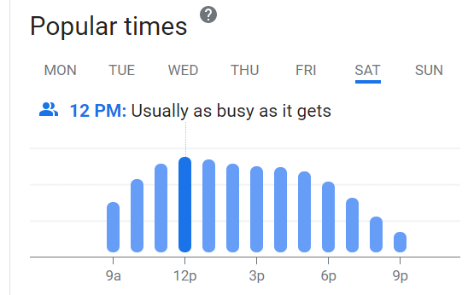

Number of Customers in Party Data Collection:
[2,2,2,4,3,2,3,1,2,3,2,2,2,2,1,2,1,2,1,3,2,3,3,2,4,2,3,2,2,4,3,2,2,1,3,4,4,2,2,1,2,3,2,2,2,4,3,2,3,2,3,2,1,3,3,2,4,3,1,2,3,4,1,3,3,2,2,1,2,2,2,2,4,1,4,2,1,1,1,2,1,2,4,2,4,3,2,2,2,2,2,3,2,3,2,3,2,3,2,4,4,2,3,2]

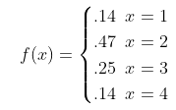

Full Results:
Real | Scaled (1/8) | 50% | 40% | 10% | Average (hours) | Max (hours) | Average(Minutes) | Max(Minutes)
1000 | 125.00 | 62.50 | 50.00 | 12.50 | 0.05 | 0.11 | 2.95 | 6.38
900 | 112.50 | 56.25 | 45.00 | 11.25 | 0.05 | 0.10 | 2.76 | 5.72
800 | 100.00 | 50.00 | 40.00 | 10.00 | 0.04 | 0.09 | 2.24 | 5.19
700 | 87.50 | 43.75 | 35.00 | 8.75 | 0.03 | 0.08 | 1.88 | 4.55
750 | 93.75 | 46.88 | 37.50 | 9.38 | 0.03 | 0.07 | 1.98 | 4.44
775 | 96.88 | 48.44 | 38.75 | 9.69 | 0.04 | 0.09 | 2.34 | 5.32
760 | 95.00 | 47.50 | 38.00 | 9.50 | 0.04 | 0.08 | 2.20 | 4.51
767 | 95.88 | 47.94 | 38.35 | 9.59 | 0.04 | 0.08 | 2.17 | 4.53
770 | 96.25 | 48.13 | 38.50 | 9.63 | 0.03 | 0.08 | 1.86 | 4.85

Bibliography
Arnold, Chris. “Ski down and Mask up - Resorts Try to Stay Safe in Pandemic Skiing Boom,” January 18, 2021. https://www.npr.org/2021/01/18/957221195/ski-down-and-mask-up-resorts-try-to-stay-safe-in-pandemic-skiing-boom.
“Cascade Mountain - Frequently Asked Questions.” Accessed March 7, 2021. https://www.cascademountain.com/faqs.
“Cascade Mountain - Snow Cam.” Accessed March 7, 2021. https://www.cascademountain.com/snow-cams.
“Detachable Chairlift,” January 28, 2021. https://en.wikipedia.org/wiki/Detachable_chairlift.
Filip, and Filip. “Ski Slope Levels,” July 3, 2020. https://skiinglab.com/ski-slope-levels/.
“How Fast DO Skiers Go?,” August 18, 2019. https://commutter.com/how-fast-do-skiers-go/.
Tate, Curtis. “Ski Season and COVID-19: What You Need to Know before You Head to the Slopes,” November 19, 2020. https://www.usatoday.com/story/travel/2020/11/18/ski-resort-protocols-amid-covid-19-what-know-before-skiing/6248199002/.
“Vail Resorts REPORTS FISCAL 2020 Fourth Quarter and Full Year Results and Provides Preliminary Season Pass Sales Results,” September 24, 2020. http://investors.vailresorts.com/news-releases/news-release-details/vail-resorts-reports-fiscal-2020-fourth-quarter-and-full-year.

http://investors.vailresorts.com/news-releases/news-release-details/vail-resorts-reports-fiscal-2020-fourth-quarter-and-full-year
https://www.npr.org/2021/01/18/957221195/ski-down-and-mask-up-resorts-try-to-stay-safe-in-pandemic-skiing-boom
https://www.usatoday.com/story/travel/2020/11/18/ski-resort-protocols-amid-covid-19-what-know-before-skiing/6248199002/
https://www.cascademountain.com/snow-cams
https://commutter.com/how-fast-do-skiers-go/
https://skiinglab.com/ski-slope-levels/
https://www.cascademountain.com/faqs
https://en.wikipedia.org/wiki/Detachable_chairlift

